horizontal line

**Delhi Technological University**

Department of Applied Physics

IVth Semester

**MICROPROCESSORS & INTERFACING**

**MPI EP - 206**

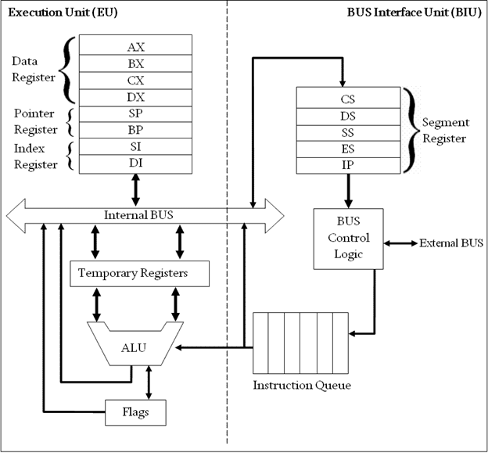

# **Submitted by :**

**ADITYA SINGH, 2K19/EP/005**

**Submitted to:**

**Dr. Rishu Chaujar**

# **Experiment 7**

**Arrange the given numbers of series in order of increasing and decreasing magnitude of numbers.**

**THEORY**

Ascending

1. SI points to 2000h memory location where the user inputs a number of terms.
2. Store number of terms-1 in CL register.
3. Store number of terms-1 in CH register and SI points to the first number.
4. Compare the current term and its next term. If the current term is greater, then exchange them, else jump to r3.
5. Decrement CH and jump to r2 until CH gets 0. When CH gets 0 decrement CL register and jump to r1 until CL gets 0.
6. The CL register acts as the counter for the number of iterations required to completely sort the given numbers. In every one iteration of the CL register the program will iterate through the entire list of numbers and the largest element will be stored at the last position and CH register will become 0 after every iteration.
7. Once the CL register goes to 0 the program terminates as all the numbers will be sorted.

Descending

1. SI points to 2000h memory location where the user inputs a number of terms.
2. Store number of terms-1 in CL register.
3. Store number of terms-1 in CH register and SI points to the first number.
4. Compare the current term and its next term. If the current term is greater, then jump to r3, else exchange them.
5. Decrement CH and jump to r2 until CH gets 0. When CH gets 0 decrement CL register and jump to r1 until CL gets 0.
6. The CL register acts as the counter for the number of iterations required to completely sort the given numbers. In every one iteration of the CL register the program will iterate through the entire list of numbers and the smallest element will be stored at the last position and CH register will become 0 after every iteration.
7. Once the CL register goes to 0 the program terminates as all the numbers will be sorted.

**CODE**

**Ascending**

**mov si,2000h**

**mov cl, [si]**

**dec cl**

**r1:**

**mov si,2000h**

**mov ch,[si]**

**dec ch**

**inc si**

**r2:**

**mov al,[si]**

**inc si**

**cmp al,[si]**

**jc r3**

**xchg al,[si]**

**xchg al,[si-1]**

**r3:**

**dec ch**

**jnz r2**

**dec cl**

**jnz r1**

**hlt**

**Descending**

**mov si,2000h**

**mov cl, [si]**

**dec cl**

**r1:**

**mov si,2000h**

**mov ch,[si]**

**dec ch**

**inc si**

**r2:**

**mov al,[si]**

**inc si**

**cmp al,[si]**

**jnc r3**

**xchg al,[si]**

**xchg al,[si-1]**

**r3:**

**dec ch**

**jnz r2**

**dec cl**

**jnz r1**

**hlt**

**OUTPUT**

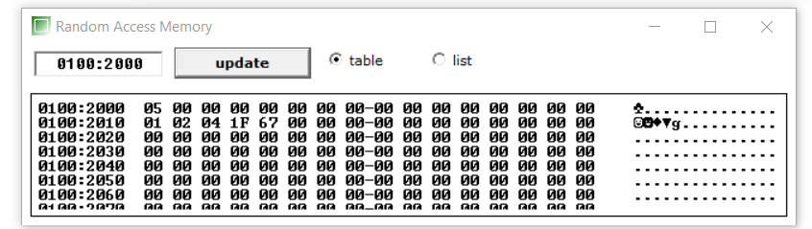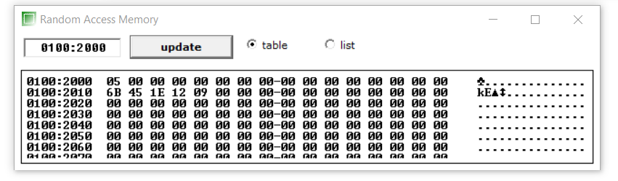

**END**